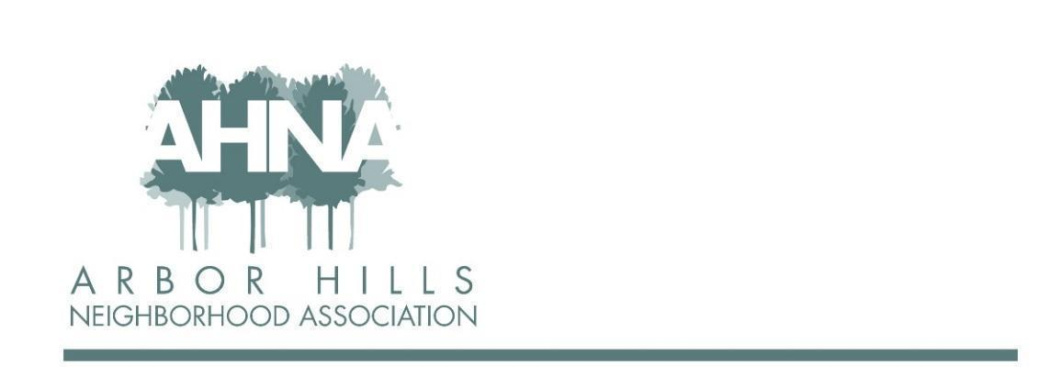
BOARD MEETING
Tuesday, March 8, 2022
Zoom

In attendance: Rebecca Koerschner, Mary Loch-Sarah, Alder Yannette Figueroa Cole, Josh Grotheer, Ashley Gibson, Neil Dinndorf , Jackie Cooper, Lisa Fernandez, Grant Roeming, George Ermert, Aaron Eiker, Nanci Horn, Nicholas Griffiths, Micheal Horeck

Absent (excused):

- Guest speaker: Alder Yannette Figueroa Cole 6:35
· From Puerto Rico, has been in Madison 30+ years. Lives in the Dunn's Marsh neighborhood for 26 years
· Spent the beginning of the pandemic in PR. Came home to all the crisis back home, specifically housing crisis as it was already a pandemic pre-covid. That drove her to run for Alder (has been doing it for a year).
· Has continued to advocate for housing security.
· One of the biggest issues in district 10 has been speeding on local streets. So has good relationships with the transportation department.
· Working on any projects that have to do with safety and prevention is important.
· On the finance committee which allows her to better understand the budget.
· Involved in the transition in the town of Madison. Fluent in both English and Spanish so she is big on helping with the transition to the Latinx community.
· Got an email from Kaiser Lincoln car dealership – as they are going to tear that building down
· Questions:
o Mary: What is your interaction with the school board? Has been in contact with the police department for. Also in contact with the transportation department. Would like to learn more about our concerns.
o Jackie: Memorial has very different concerns than west. How familiar are you with arbor hills and the west attendance area? That is what she is here to do, she wants to hear from us. Will need support from us to make things successful.
o George: Where do you stand on where the south police district is on staffing as we get feedback that we don’t have enough police presence here? Barnes has a plan in place to address the car theft issue across the board. We’ll need to work with the police to make sure these are not crimes of opportunity. Education is important to make sure we are taking the right safety measures.

- Approval of January Meeting Minutes & Review Follow Ups – Jackie 6:54
Motion to approve January minutes. Mary motions. Josh seconded
Follow ups:
· replacing the signs. Grant sent over a proof for the signs (food truck night, garage sales etc.)
· re-ordering the envelopes. Will be ready for the next newsletter edition
· Membership lists. Jackie is still working on this
· Ad-revenue updates (will get update on later)
· George to lead sub-committee on membership – still outstanding

- Membership Update - Jackie 6:57
· 31 members paid so far
· 6 new, 17 paid online
· Paypal fee has increased (1.19 per 20 membership)
o Right now we are paying for the fee
o Follow up: Talk to the website admin (Wanda) about if we can do anything to include the fee for paying online.
· Goal is 175 members
· Q: When someone moves out and they are using the auto deduction, who is responsible for updating that? A: They would be responsible for canceling this. And then if they want a refund they would go through Mary. 2022 is the first year that we have recurring payment as an option

- Budget - Mary 7:05
· YTD 17 members. We are behind compared to prior years. But this may be because we haven’t had the October meeting and we didn’t have the cards yet this year
o Jackie has 31 members. This discrepancy is due to members paying in March and the budget going through EOM Feb
o Follow Up: Board members PAY YOUR DUES!
· Checking 1,441.75, savings 6,725.82
Haven’t typically needed to draw from savings but took 1,000 from savings due to a lag in income and hope to transfer that back later in the year

- Ad Partners - Josh 7:11
· Josh will need to get with Mary to see who has paid through the end of last year.
· Back of the envelope math we are looking to exceed the budgeted 1500 by 220-370 (based on the current ad commitments). Some of this is due to late payments from the previous year.
· Invoices are going out next week, so we should see some $$ coming in
· Aaron to follow up with Radiance about getting in the ad-game.
· The spring newsletter is already set. Any new ads would be for summer or later.
· Q: Is our newsletter just going to be ads? Do we need to add another page? We have had some conversations about adding a page, but we would have to add 4 pages because of how the newsletter is constructed. And then it would become a lot larger.
· We could offer for businesses to sponsor an event instead of buying ad space if it becomes too ad-heavy.
- Events - Nanci & Aaron 7:18
· We have an events calendar!
· Nanci coordinated the first event of the year! Had a sledding pop-up event.
o The hill has been very popular this year!
· Usually, the July event is in the morning, Nanci to update to the AM
· Halloween event has been in the afternoon (3p last year). Recommend we do around 3p again. Update to parade that’s ending in the park (similar to last year).
o Idea to do some spooky photos of families/kids in their costumes. Would be fairly easy for Aaron to do for free too.
· New event! Chili Cookoff in November.
o People make big vats of chili. Can make it a donation to another organization or it could be a tasting event.
o Option to make it a members only event to make membership more attractive.
· About 1 event/month April -October
· Need to add the annual meeting to the event in October (date TBD)
o Follow Up: Add a conversation to the May meeting agenda about annual meeting planning or hash it out over email.
· When we have events it is an opportunity to capture members as we have lots of non-members attend. We have a credit card reader and could set up a table to collect dues.
o Should we buy an association banner or a sign that has a QR code that points to the website?
§ The QR code would be easy to do
§ Also have membership forms for folks who still want to pay by cash or check!
o Establish an owner who is responsible for each prior to each event. Nanci and Aaron will own making sure there is an owner for each
§ A sign for events that has QR code on it – Grant will loop this into the sign creation he’s working on
§ Print out membership forms – Jackie
§ Someone at each event who owns the square to collect payments

- Arbor Hills Sign Landscaping -Grant 7:35
· Have $50 for neighborhood improvements as a line item in the budget
· We have typically had this landscaping done by volunteers. We used to have a garden club. What happened to that?
· Need to put out a call for action to get volunteers to help. Could we group it with earth day next month?
· Follow Up: Ashley and Grant to have a follow up discussion to see if it is something that could be done by volunteers or if it needs to be professionally done. And bring it back to the board

- Block Captains - Nicholas 7:41
· A few new block captains
· Only one known vacancy (Ardlsey, Greenway, McDivitt). Would like to get a separate block captain for each of those blocks if possible. Will need a few extra hands likely for the spring newsletter.
· Possibly looking to do an event with the block Captains and the board. Have done something similar (coffee with the board at Jim’s) in the past.
o Thinking about doing something in the park in the summer when the weather is nice.
· Lisa volunteering to be a block captain on one of the vacant blocks.
· Follow up: Nicholas to collect the phone numbers of the block captains

- Newsletter - Michael 7:47
· Still don’t have a newsletter designer. We have hired a freelancer that we have used in the past it’s $360 + per newsletter, which is expensive.
· Continue to look for someone local in the neighborhood who can do this for free
· Looking to go down to just a color cover and a black and white interior. Would save us $110 per edition. Would be to try to mitigate some of the additional cost of hiring someone to design the newsletter.
· Remittance envelopes (600) are printed. Will be sending them to Nicholas and we can stuff them in every single newsletter that goes out.
o Will either stuff them himself or ask the block captains to do it
· Jackie suggestion: Add info in the newsletter about the cost of a single newsletter
· Discussion about if we can sacrifice on layout to save the $$.

Planning to meet in person in May!
· Brainstorming with Josh and George on where to go
· (1) Nearby, (2) food, (3) somewhere where we can talk to one another
· Leaning towards Licari’s – no private space, and kind of noisy, but could work
· Ideas: Funks pub (Aaron to reach out), Great Dane Fitchburg (Ashley to reach out)
· Follow ups: Ashley to send out a poll!
Follow up: Everyone to review the newsletter when Michael sends it out!

- Adjourn 8:00

