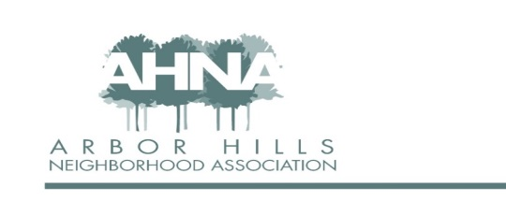

Block Party Reimbursement Request
The Arbor Hills Neighborhood Association encourages members to host block parties to build relationships with neighbors and create a stronger community. AHNA will reimburse up to $100 for block party-related expenses. The event must be open to everyone on the street (i.e., not a private party) and communicated via print or E-mail to all residents of the block. After the party, please submit any receipts for food, soft drinks, paper products, charcoal, ice, decorations, or other party-related expenses EXCEPT alcoholic beverages.
Please include the following documents with your request:
• Copy of print or e-mail invitation
• One or more pictures or links to photos taken at the event
• Receipt for items to be reimbursed

Contact Information
Name:_______________________ Address:_____________________________
Phone:_______________________ E-mail Address:____________________

Event Details
Block Party Date and Time:_________________________
Location - Street Name(s):__________________________
Number of Homes Invited: _______ Approximate Number of Attendees: _______

Approval
Reimbursement Amount Requested: $_________
Board Member Signature: __________________ Date: __________

Please e-mail or drop off your request to:
Neil Dinndorf
AHNA Treasurer
nrdinndorf@gmail.com
3314 Westview Ln
(608) 886-5375

